**Vehicular Ad-hoc Simulation and Nodal Communication in a Adaptive Environment**

**Cody Ryan, Ethan Park, Sayra Ramirez, and Aditya Sidher**

**CPE 400 Project**

**1 Introduction:**

Vehicular ad hoc networks (VANETs), a variation of mobile ad hoc networks (MANETs), are becoming increasingly important in Intelligent Transport Systems (ITS), since they provide a multitude of services to the passengers in the vehicle. VANETs use moving vehicles as nodes to create a network. The difference between MANETs and VANETs is that VANETs tend to move in a distinctive pattern, usually defined by streets, and are also fast-moving. VANETs aim to provide communication between vehicles and roadside units or other vehicles. Examples of this are OnStar and other navigation services. With these services, peace of mind and safety are increased for the passengers. So, why keep advancing this network? The problem with this sort of network is the drop in communication. When this occurs, some data may be lost. This will result in less reliable safety services. Within this project, we study the realistic nodal movements in the simulation and the behaviors of their communications between one another in a VANET environment.

**2 Project Description:**

**2.1 Components of the Project:**

To start, this project was completed using NS-3.29, a trace file containing a traffic grid in Manhattan, and NetAnim. NS-3.29 is a library of code that helps develop a network simulator. This allows the group to focus on creating what happens within the simulation and not on making it. The Manhattan traffic grid trace file was taken from BonnMotion and is used to simulate cars moving in a realistic scenario, specifically in a metropolitan area such as Manhattan. The simulation demonstrates wireless access in vehicular environments (WAVE) and how they connect to other WAVE points while the nodes move around in the area. For this simulation, nodes act as if they are vehicles. Then lastly, NetAnim helps visualize what the network would look like if it was a realistic network. The group would have liked to set up Simulation of Urban Mobility (SUMO) but due to its setup within our lab, we were unable to do so. SUMO would have allowed the group to choose any urban location in the world to test the simulation, but since the group could not get SUMO working, the group decided to take an already generated trace file provided by BonnMotion.

**2.2 Simulation Setup:**

The team’s simulation consists of 50 nodes. The nodes are mobile and dynamically move throughout a mapped-out area within the Manhattan tracefile. During this movement, their WAVE radius can be seen, as well as their connect possibilities. WAVE’s standard, IEEE 802.11p, an approved amendment to IEEE 802.11, defines the methods to transfer data through a link without a basic service set (BSS) establishment [wikipedia, website]. This allows for the adaption to links to only exist for short intervals, similar to the team’s simulation scenario. Within the wave class, the GPS accuracy is measured in nanoseconds. This is for more precise readings. GPS accuracy is very important for this simulation because, without it, the data would not be as accurate. It would not detect other nodes as soon as it does.

Each node has its own Wifi/MAC which can handle things like packet size, number of packets sent, and the time intervals between each packet. Under the Wifi class, it can be seen how it establishes the connection between WAVE and MAC. It wouldn’t be possible to perform this study with a wired network. So that option unfortunately wasn’t able to be pursued. For transmitting the data, the simulation uses UDP. Due to this, some packet loss is expected but UDP was chosen so that when a packet is received, it is always correct. Another important routing protocol used is ad hoc on-demand distance vector routing (AODV). This is used to aid in the wireless connection between the nodes while running on IPv4.

**3 Analysis:**

**3.1 Results:**

The program generates Simulation.xml which allows the simulation to be run in NetAnim. From NetAnim, the group was able to visually see the simulation (see figures below) and collect data recorded by NetAnim. The program also generates output files that output additional data. The results the group was able to collect included AODV routing tables for 5 and 12 seconds, tracing, node movement, and metadata (node movement and meta data were output from netanim). These were recorded in the output files SimulationRoutes_12S.routes, SimulationData_5S.txt, NodeTrajectory, SimulationMetaData.txt, and SimulationTrace.tr, respectively. This data will be sent along with the source code, however, some samples will be provided below.

This is one example of tracing generated from the simulation:

*t 1.10362 /NodeList/19/$ns3::Ipv4L3Protocol/Tx(0) ns3::Ipv4Header (tos 0x0 DSCP Default ECN Not-ECT ttl 64 id 0 protocol 17 offset (bytes) 0 flags [none] length: 540 10.1.0.20 > 10.1.0.10) ns3::UdpHeader (length: 520 49153 > 9) Payload (size=512)*

*AODV Routing table*

| ***Destination*** | ***Gateway*** | ***Interface*** | ***Flag*** | ***Expire*** | ***Hops*** |
| --- | --- | --- | --- | --- | --- |
| *10.1.255.255* | *10.1.255.255* | *10.1.0.1* | *UP* | *9223372024.85* | *1* |
| *127.0.0.1* | *127.0.0.1* | *127.0.0.1* | *UP* | *9223372024.85* | *1* |

Table 1: This is one example of a AODV routing table generated by the simulation

NetAnim Node Trajectories

| *Time* | *X-Coord* | *Y-Coord* |
| --- | --- | --- |
| *0* | *216.278* | *2010* |
| *0* | *216.278* | *2010* |
| *0.25* | *219.312* | *2010* |
| *0.381207* | *220.904* | *2010* |
| *0.381207* | *220.904* | *2010* |
| *0.5* | *222.284* | *2010* |
| *0.75* | *225.188* | *2010* |
| *1* | *228.092* | *2010* |

Table 2: This is a sample of node trajectories generated by NetAnim:

NetAnim Metadata

| *From Id* | *To Id* | *Tx* | *Meta* |
| --- | --- | --- | --- |
| *35* | *25* | *0.005* |  |
| *35* | *0* | *0.005* |  |
| *35* | *4* | *0.005* |  |
| *35* | *2* | *0.005* |  |
| *20* | *38* | *0.00609834* |  |
| *20* | *28* | *0.00609834* |  |
| *20* | *48* | *0.00609834* |  |

Table 3: This a sample of meta data generated from NetAnim

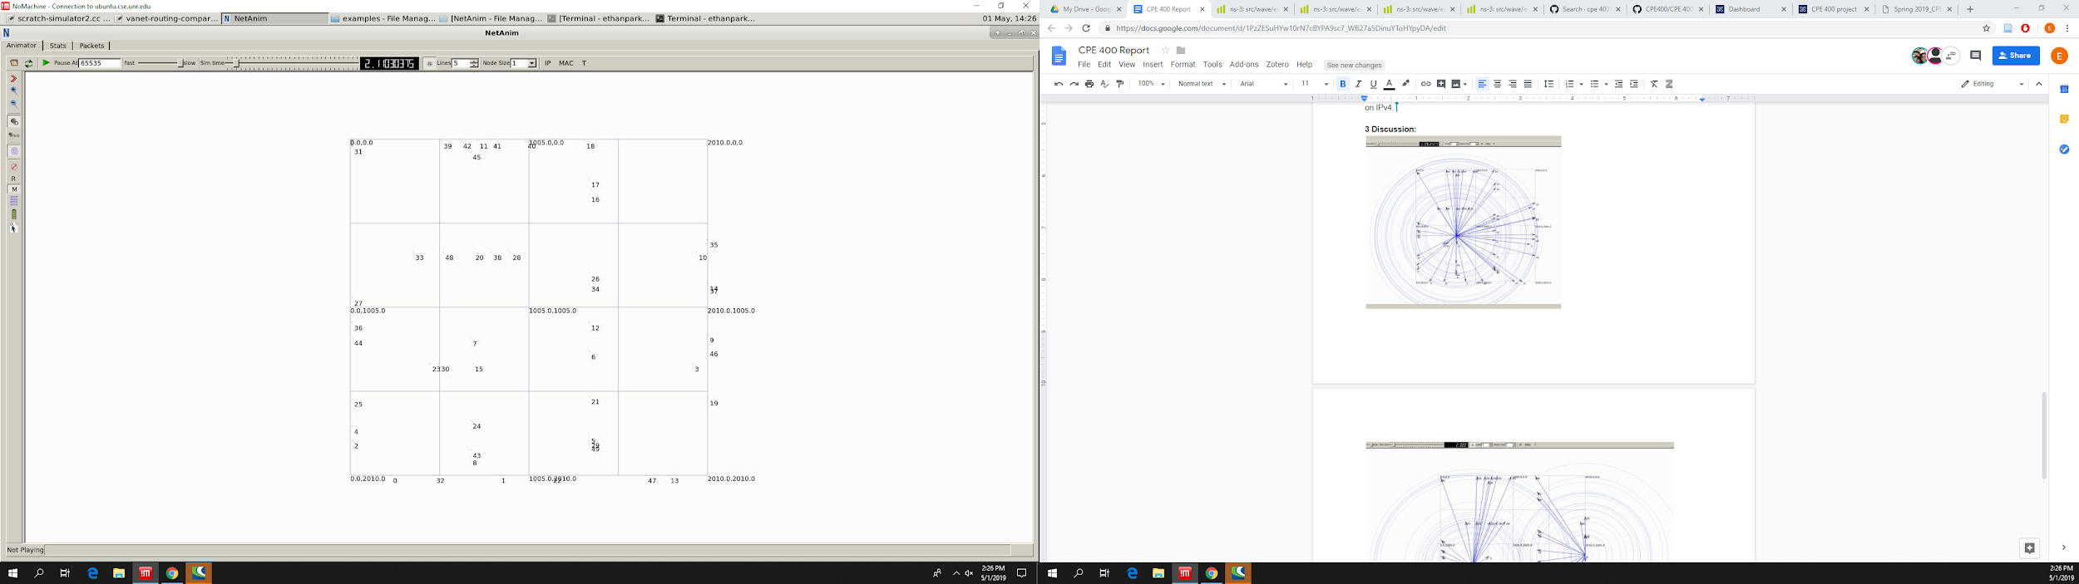

*Figure 1: The 50 nodes are arranged in a grid fashion, demonstrating a street-like pattern.*

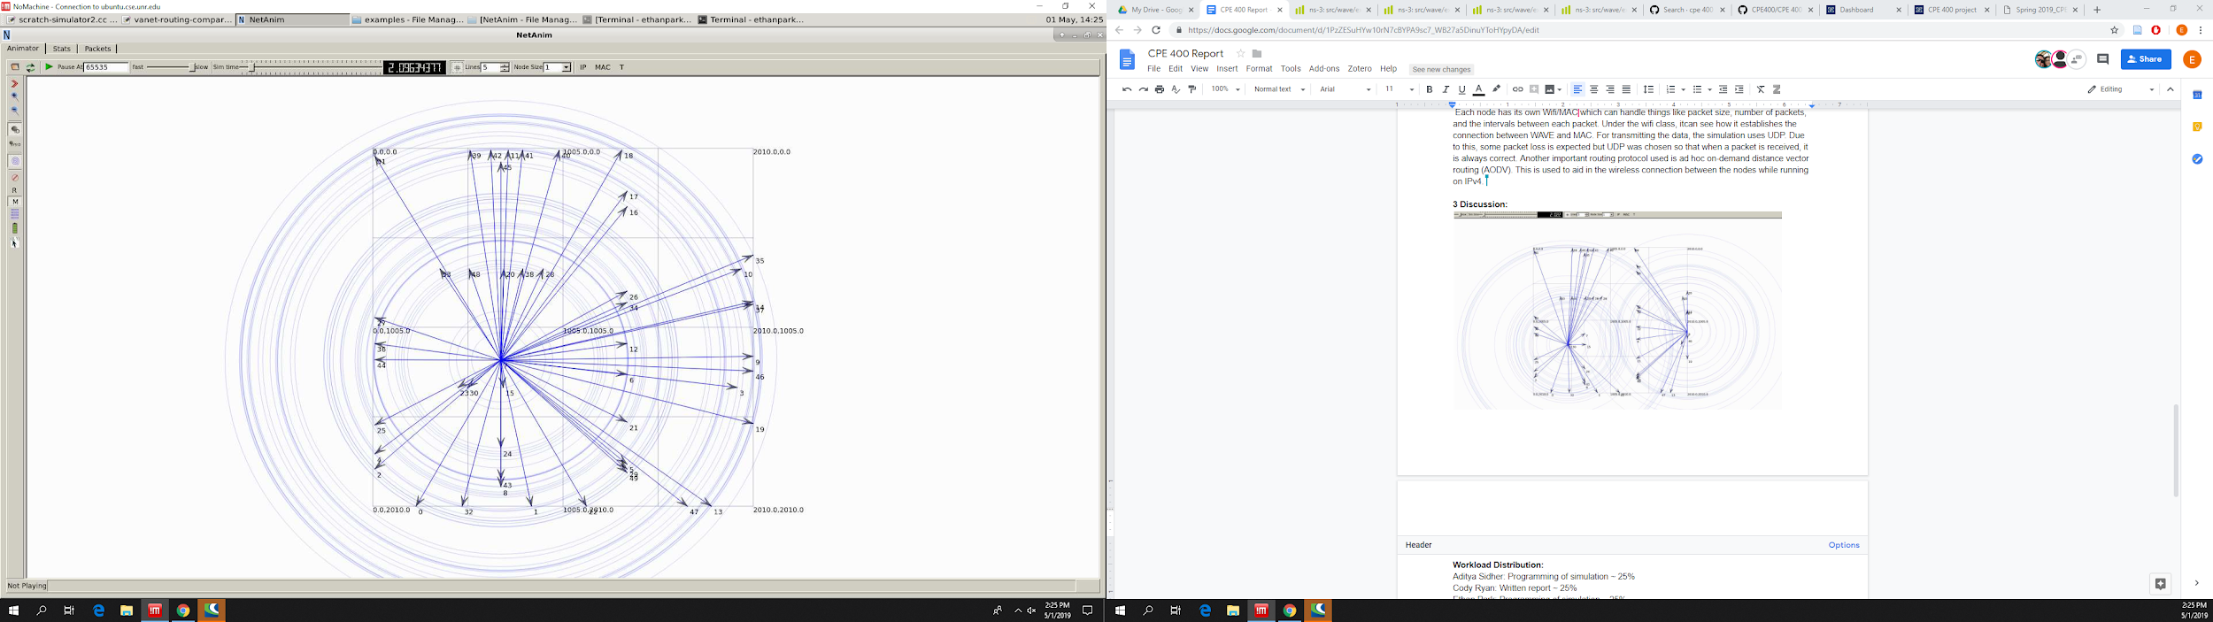

*Figure 2: When setting the Tx power to 20, the connection radius of the current node is within range of all other nodes.*

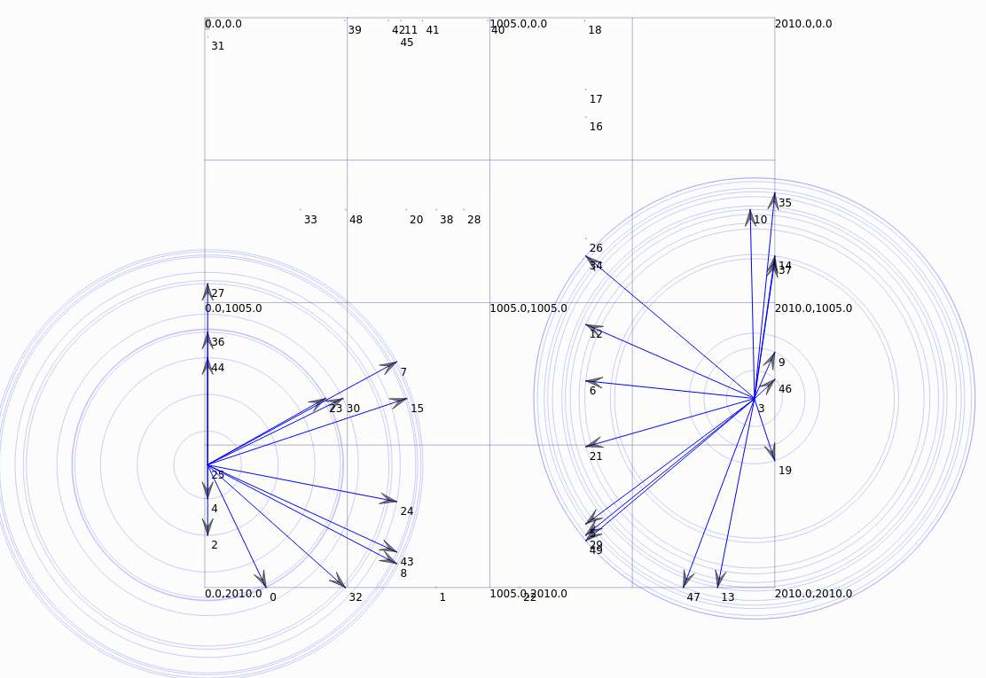

*Figure 3: When setting the Tx power to 10, the connection radius of each node significantly decreases, with all nodes outside the radius being out of range*

**3.2 Analysis of Results**

The results from NetAnim show that the nodes are able to move in a way that simulates vehicles moving through traffic. This is shown in Figure 1, as the nodes are set up in a way that represents a traffic grid. Additionally, the node trajectories generated by NetAnim further support this conclusion, as the nodes move in a way that simulates vehicles moving on city streets.

The AODV routing table and tracing as well as the metadata from NetAnim show that that the nodes are able to communicate with one another. The routing table and tracing generated from their respective files the protocols being used by nodes to communicate as well as additional data on the communication process. The NetAnim metadata supports this conclusion as it shows one node (indicated by From Id) communicating with another node (indicated by To Id).

NetAnim also shows the strength of connections between nodes in the simulation. Figure 2 shows that when Tx power is increased, the current node is able to transmit to nodes that are further away. Figure 3 shows the opposite result, as decreasing Tx power will decrease the connection radius.

In short, the results show the simulation was successfully able to reproduce the movement of nodes in a way that mimics vehicles and how these nodes communicate with each other.

**4 Conclusion:**

VANET models can be better used to simulate traffic information to improve GPS navigation. The models are still relatively new as autonomous vehicles still have room for improvement. With better technology, the VANET models can closely simulate real scenarios that can help improve traffic communication between vehicles. Our simulation shows nodes representing vehicles with wifi being able to communicate with other vehicles in range.

**Workload Distribution:**

Aditya Sidher: Programming of simulation ~ 25%

Cody Ryan: Written report ~ 25%

Ethan Park: Programming of simulation ~ 25%

Sayra Ramirez: Written report ~ 25%

**References:**

Wikipedia (website). <https://en.wikipedia.org/wiki/IEEE_802.11p>

Node Trajectory file: <https://groups.google.com/forum/#!topic/ns-3-users/3-N0HyiZIJE>